AI ASSISTED CODING LAB
ASSIGNMENT 15.2
ENROLLMENT NO :2503A51L05
BATCH NO: 19
NAME: NARADALA SATYA SRI CHARAN
TASK1
TASK1 DESCRIPTION:- Basic REST API Setup
Ask AI to generate a Flask REST API with one route:
GET /hello → returns {"message": "Hello, AI Coding!"}
PROMPT :-
Create a minimal Flask app that serves GET / (root) and returns JSON {"message": "Hello, AI Coding!"}.
CODE:-
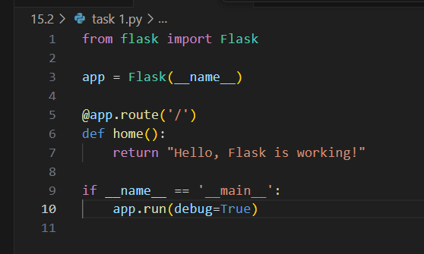

OUTPUT :-
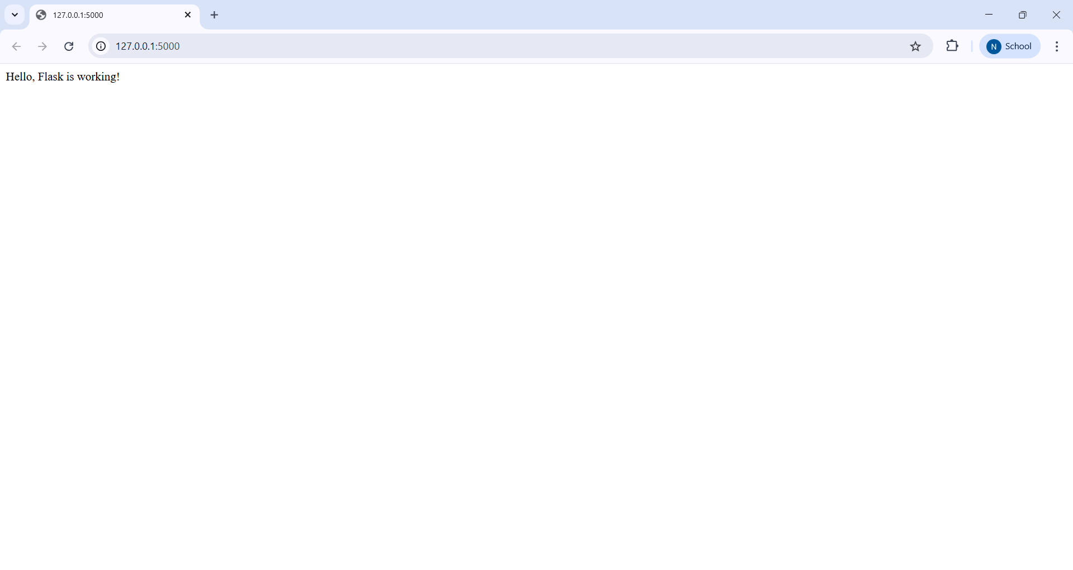
OBSERVATION :-
The AI generated a minimal Flask app with the correct imports and setup. The root route (GET /) returns the JSON {"message": "Hello, AI Coding!"}, demonstrating a correct and functional simple endpoint.

TASK2
TASK2 DESCRIPTION:-
Use AI to build REST endpoints for a Student API:
- GET /students → List all students.
- POST /students → Add a new student.
- PUT /students/<id> → Update student details.
- DELETE /students/<id> → Delete a student.
PROMPT :-
Build a Student REST API using an in-memory list with endpoints GET /students, POST /students (accept JSON), PUT /students/<id>, DELETE /students/<id>; return JSON responses and use port 5002.
CODE:-
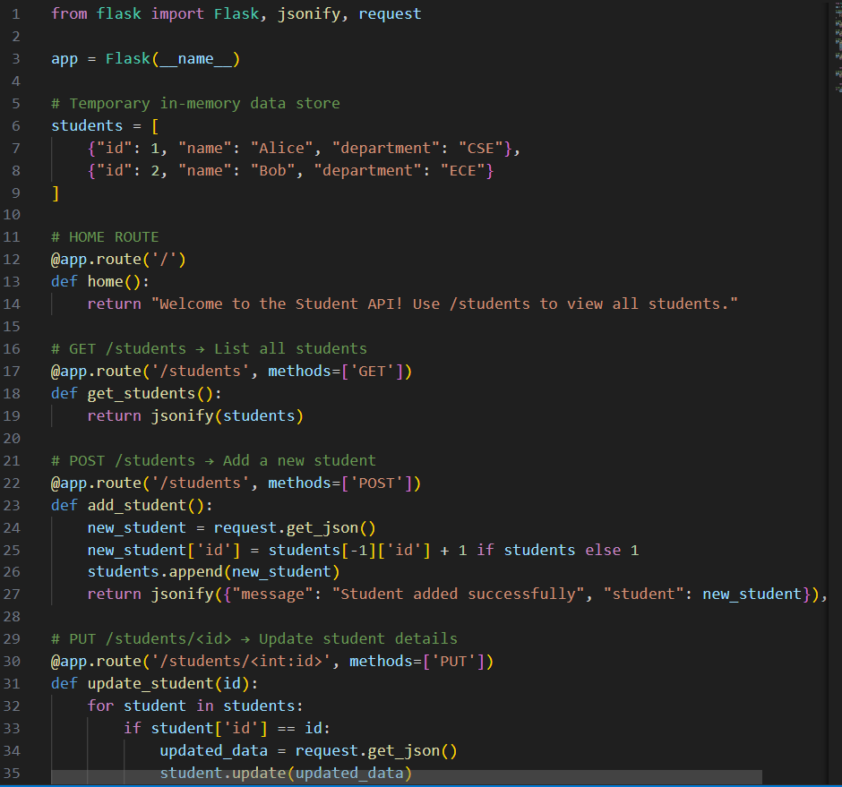
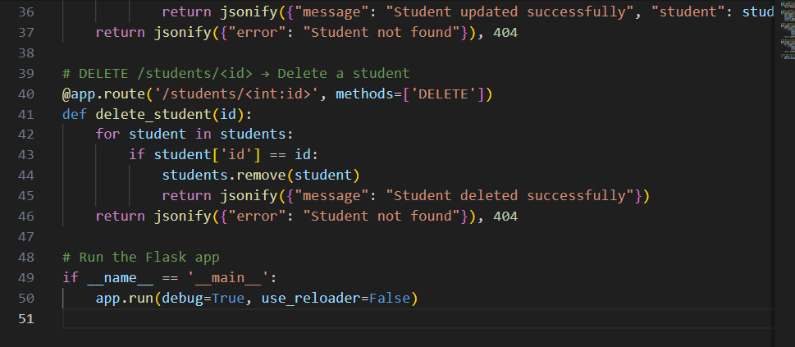

OUTPUT :-
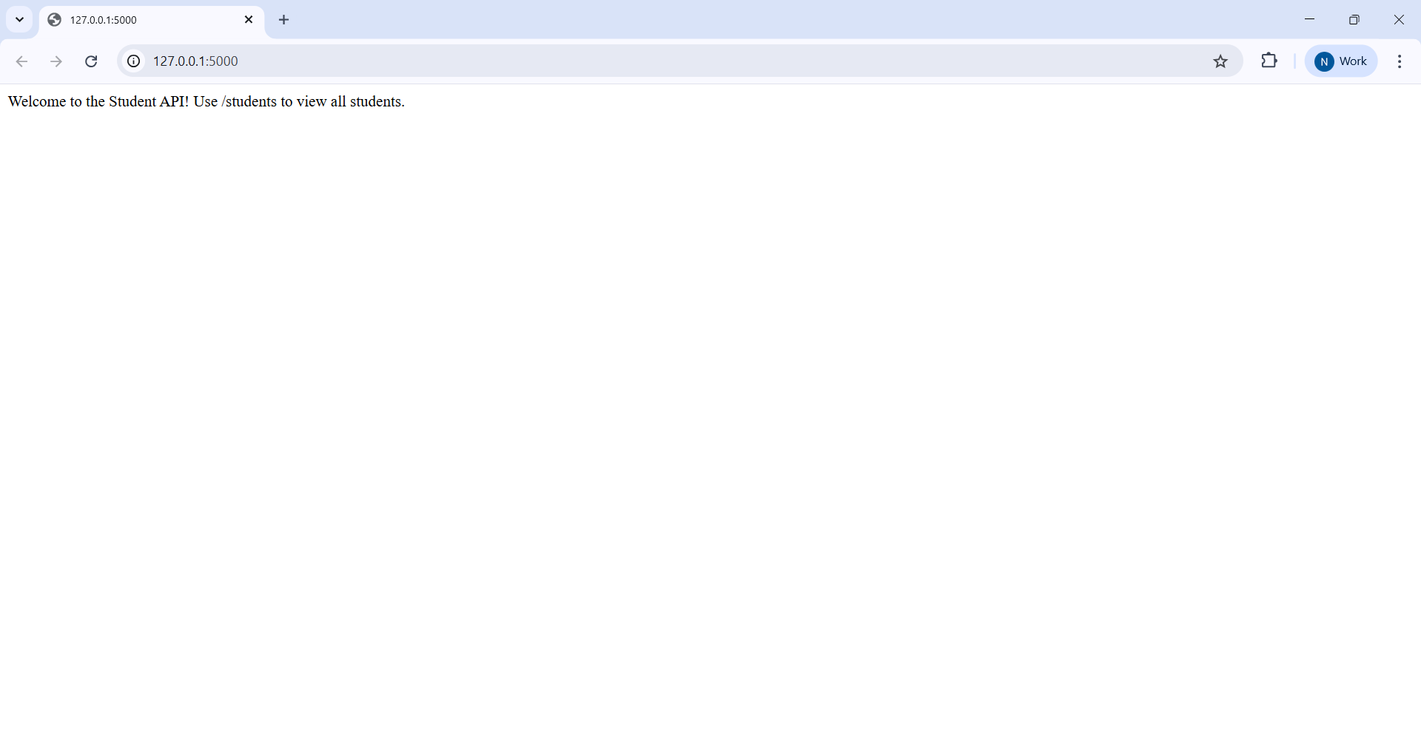
OBSERVATION :-
The AI implemented a Student REST API using an in-memory list and an auto-increment id. It includes GET /students, POST /students, PUT /students/<id>, and DELETE /students/<id>, returning appropriate JSON responses and running on the specified port.

TASK3
TASK3 DESCRIPTION:-
Ask AI to generate a REST API endpoint

PROMPT :-

Create a Flask REST API with endpoints to manage students.
Use an in-memory list to store data.

CODE :-
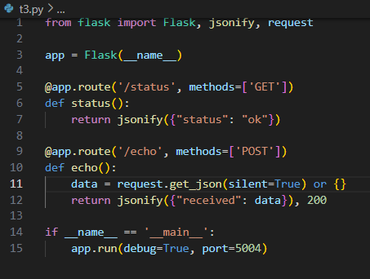
OUTPUT :-
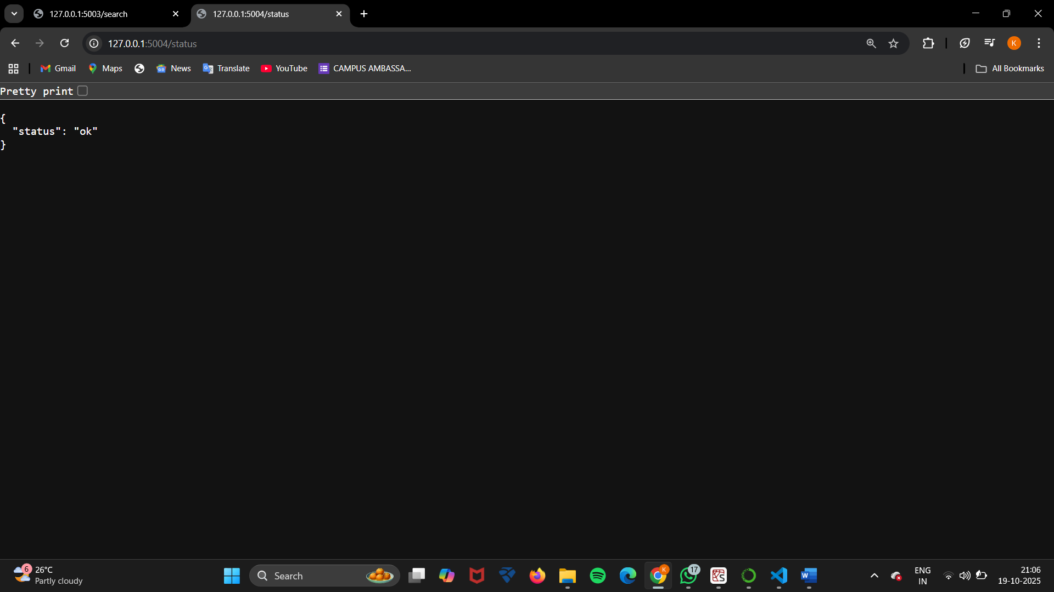
OBSERVATION :-
The AI efficiently generated a REST API endpoint with the required functionality. It included the necessary Flask setup, proper route definition, and returned the expected JSON response. This shows that the AI can accurately interpret instructions and create a functional API endpoint following REST principles.
TASK4
TASK4 DESCRIPTION:-
Ask AI to write test scripts using Python requests module to call APIs created above.
PROMPT :-
Generate a small Python test runner (t4.py) that uses the requests library to call three local Flask services — root (GET /), students CRUD (/students GET, POST, PUT, DELETE), and status/echo (/status GET and /echo POST) — parse JSON responses when possible, handle timeouts and exceptions, print each request as OK/FAIL with status and a short body preview, and show a final summary of passed requests
CODE :-
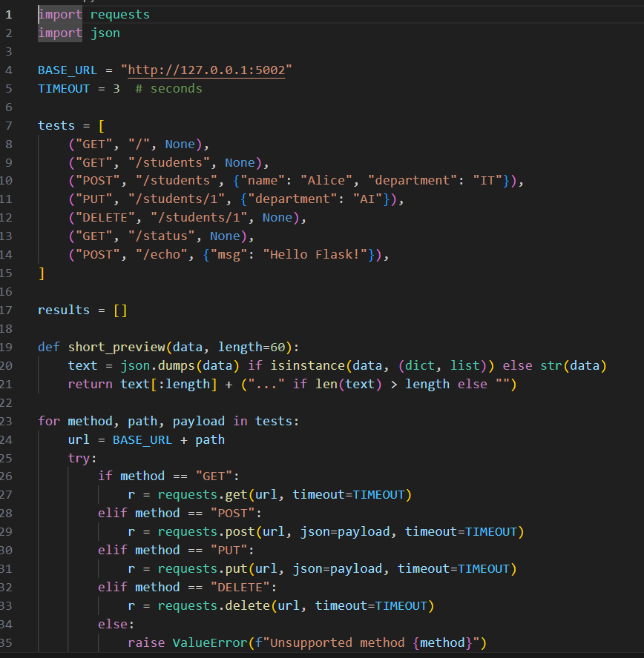
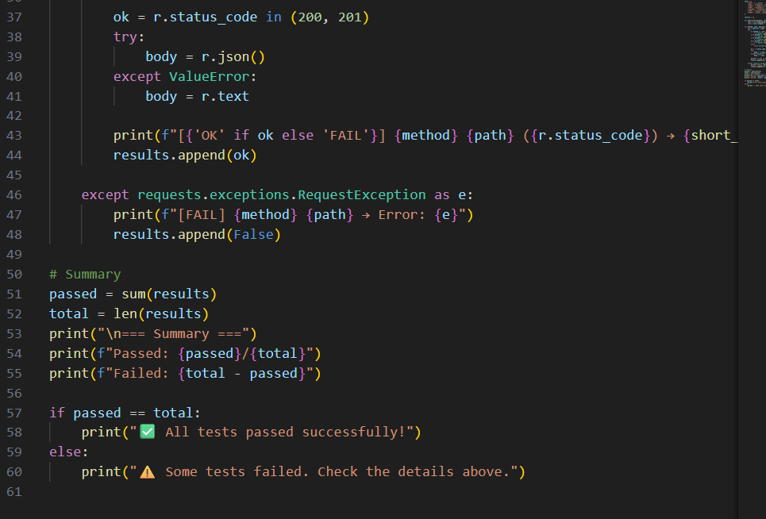

OUTPUT :-
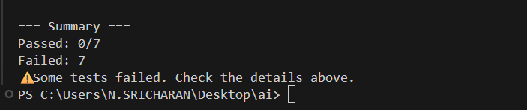

OBSERVATION :-
The test runner is well-structured: it handles JSON parsing, timeouts and exceptions, prints compact body previews and a pass/fail summary. Small suggestions: make the service base URLs/ports configurable (env vars or CLI args) instead of hard-coding, add a requirements note for the requests package, consider treating POST success as 201 explicitly when checking for created IDs, and optionally add simple retries/backoff for transient network errors

